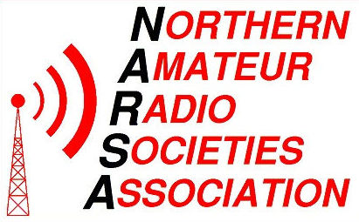

Construction Competition 2017 Rules.
(Organised by Warrington Amateur Radio Club.)

Bill Sparks Trophy - Colin Fox Novice Trophy

The construction competition is open to any individual or club member attending the N.A.R.S.A exhibition.

Entries should be taken to the Warrington Amateur Radio Club stand on the day of the exhibition or arrangements should be made for entries which form part of a club stand display or activity.

A numbered entry form must be filled out in full and signed by the individual wishing to enter an item in to the construction competition.

The information on the entry form will include:-
Name of the person.
Call Sign. **
Full postal address.
Contact telephone number.
Occupation.
Radio Club. **
Description of equipment.
Cost and status of project.
Rated ability. ** If applicable.

The Warrington Amateur Radio Club will arrange judges and judging of competition. Arrangements can be made for judges to visit club stand if the entry is part of a club stand.

All entries will be judged together and The Bill Sparks trophy will be awarded to the overall winner of the construction competition. The rated ability of each entry will be taken into account when equipment is judged. This allows for advanced and novice entries to be judged on an equal footing.

The Colin Fox trophy will be awarded to the best entry by a novice, or in the case of a novice receiving the Bill Sparks trophy, the trophy will be awarded to the best of the remaining novice entries.

The Warrington Amateur Radio Club as organiser of this competition, on behalf of N.A.R.S.A cannot be held responsible for any loss, or damage to equipment entered into the competition.

Construction Competition – 2017, Entry Form.
(Organised by Warrington Amateur Radio Club.)

Entry No: _________

Full Name: _________________________________ Call Sign: _________**

Address: _________________________________

_________________________________

_________________________________

Home Phone No: ___________________________

Email address: _____________________________

Occupation: _______________________________

Radio Club: _______________________________ ** (** If applicable)

Description of Equipment: _________________________________________

______________________________________________________________

______________________________________________________________

Approximate cost of project: £ _______

Is project: 1) Working Yes / No [ ]
2) Complete Yes / No [ ]
3) Own design Yes / No [ ]
4) Design from magazine Yes / No [ ]
5) Build from kit Yes / No [ ]

Please rate your ability. ( Tick appropriate box )

- Novice [ ]
- Some experience [ ]
- Semi-expert [ ]
- Expert [ ]
Notice to Entrants:

The Warrington Amateur Radio Club, as organiser of this competition, on behalf of N.A.R.S.A cannot be held responsible for any loss, or damage to equipment entered into this competition.

Signature: _______________________________

